**Patient-Specific Thresholds and Doses of Intracranial Hypertension in Severe Traumatic Brain Injury: The Role of Pressure Reactivity**

Christos Lazaridis MD,1 Ming Yang MS,2 Peter Smielewski PhD,3 David K. Menon MD, PhD, FMedSci,4 Peter Hutchinson FRCS (SN), PhD,3 John D. Pickard FRCS, MChir, FMedSci,3 Marek Czosnyka PhD3

1. Division of Neurocritical Care, Baylor College of Medicine, Houston, TX, USA
2. Division of Biostatistics, School of Public Health, University of Texas, Houston, TX, USA
3. Academic Neurosurgical Unit, University of Cambridge Clinical School, Cambridge, UK
4. University Department of Anaesthesia, Addenbrooke’s Hospital, University of Cambridge, Cambridge, UK

Corresponding Author: Christos Lazaridis M.D.

Department of Neurology, Divisions of Neurocritical Care and Vascular Neurology, Baylor College of Medicine, 6501 Fannin Street, MS: NB320, Houston, TX 77030, USA

Phone: (469)878-9852

lazaridi@bcm.edu

This work was performed in the Academic Neurosurgical Unit and the Neurosciences Critical Care Unit of Addenbrooke’s Hospital, University of Cambridge, Cambridge, UK. This manuscript has not been previously published in whole or in part or submitted elsewhere for review.

**Conflicts of Interest and Source of Funding:** The software for brain monitoring ICM+ (http:// www.neurosurg.cam.ac.uk/icmplus) is licensed by the University of Cambridge (Cambridge Enterprise). Mr. Czosnyka and Mr. Smielewski have a financial interest in a part of the licensing fee. Mr. Hutchinson is supported by an Academy of Medical Sciences/Health Foundation Senior Scientist Fellowship and grants from the Medical Research Council/NIHR. Mr. Menon is supported by funding from the Medical Research Council, the NIHR Cambridge Biomedical Centre, and an NIHR Senior Investigator award. Mr. Pickard is a NIHR senior investigator awardee and a principal investigator within the NIHR Biomedical Research Centre (Cambridge University Hospital Foundation Trust) and lead principal investigator for the Medical Research Council “Acute Brain Injury Programme” grant. Dr. Lazaridis and Mr. Yang have not disclosed any potential conflict of interest.

**Introduction:** Based on continuous monitoring of the pressure reactivity index (PRx) we defined individualized intracranial pressure (ICP) thresholds by graphing the relationship between ICP and PRx. We hypothesized that an “ICP dose” based on individually assessed ICP-thresholds would correlate closer with 6-month outcome when compared to ICP doses derived by the recommended universal thresholds of 20 and 25 mm Hg. **Methods:** Data from 327 severe traumatic brain injury (TBI) patients were analyzed.Intracranial pressure doses were computed as the cumulative area under the curve above the defined thresholds in graphing ICP versus time. The term Dose 20 (D20) was used to refer to an ICP threshold of 20 mm Hg. The marker D25 and DPRx were calculated similarly. The discriminative ability of each dose on mortality was assessed by ROC analysis using 5-fold cross validation (CV).

**Results:** Mean D20 was 1055 mm Hg*hour versus 478 mm Hg*hour for DPRx (p < 0.0001). Despite been half the dose, DPRx was the best predictor of mortality [DPRx AUC 0.77 (95% CI 0.68-0.89), D20 0.72 (95% CI 0.66-0.81) and D25 0.65 (95% CI 0.56-0.73)].

**Conclusion:** Individualized doses of intracranial hypertension were stronger predictors of mortality than doses derived from the universal thresholds of 20 and 25 mm Hg. The status or cerebrovascular pressure reactivity is critical on the association between dose of intracranial pressure and mortality in severe traumatic brain injury.

**KEY WORDS:** intracranial pressure; cerebrovascular pressure reactivity; neuromonitoring; clinical outcome; traumatic brain injury

**INTRODUCTION**

Intracranial hypertension has been closely linked to adverse outcomes after severe traumatic brain injury (TBI). Data from observational studies and non-controlled series have suggested thresholds ranging from 15 to 25 mm Hg [8, 12, 14, 1, 16]. The Brain Trauma Foundation’s (BTF) latest guideline has identified a lack of level-1 evidence and recognized that rather than accepting a generic, absolute intracranial pressure (ICP) threshold, an attempt should be made to individualize thresholds based on patient characteristics [3]. Cerebrovascular pressure reactivity is defined as the ability of vascular smooth muscle to respond to changes in transmural pressure and represents one of the key mechanisms responsible for autoregulation of cerebral blood flow [13]. Pressure reactivity can be determined by observing the response of ICP to changes in mean arterial pressure (MAP) and monitored via the pressure reactivity index (PRx) as suggested by Czosnyka et al. [6, 7, 17] We defined patient-specific, pressure reactivity-guided ICP thresholds by graphing the relationship between ICP and PRx over the total monitoring time for each patient. We hypothesized that an “ICP dose” based on a disturbed pressure-reactivity ICP-threshold would correlate closer with clinical outcome when compared to an ICP dose calculated by using the generic, recommended thresholds of 20 and 25 mm Hg. The full findings of this study have been published elsewhere. Here, we provide a synopsis of our work and make a further comment relating to our findings on doses of intracranial hypertension.

**MATERIALS AND METHODS**

We retrospectively analyzed anonymized digital recordings of ABP and ICP waveforms from 327 consecutive patients with severe TBI, admitted to the neurocritical care unit at Addenbrooke’s Hospital between 2003 and 2009. The clinical outcome was assessed at 6 months using the Glasgow Outcome Scale (GOS) [10]. Physiologic signals were recorded using a laptop computer with ICM+ software (University of Cambridge, Cambridge Enterprise, Cambridge, UK, http:// [www.neurosurg.cam.ac.uk/icmplus](http://www.neurosurg.cam.ac.uk/icmplus)) [15]. The PRx was calculated as a short-term moving Pearson correlation coefficient between changes in 30 consecutive, 10 seconds averages of ABP, and corresponding ICP signals (with 80% overlap of data). Based on the continuous measurement and monitoring of PRx we defined patient-specific, individualized ICP thresholds. These thresholds were visually identified from graphs of PRx versus ICP over the total monitoring time for each patient individually. The cut-off used was: PRx > 0.2; The value for the ICP threshold was only accepted if the graph showed a distinct change of PRx values from less than 0.2 to consistently exceeding 0.2. In order to quantify the physiologic insult from intracranial hypertension we computed “ICP dose” as the cumulative area under the curve above a defined threshold. The trapezoidal method was used to calculate doses from graphs of ICP versus time; the ICP “dose” is measured in mm Hg*hour [18]. For an ICP threshold of 20 mm Hg we named this dose D20. Using the same methodology we calculated D25 and DPRx. Identification of ICP thresholds and calculation of doses, were blinded to clinical outcome.

**Statistical Analysis:** The predictive ability of each dose on mortality was assessed. Receiver operating characteristic (ROC) curves were calculated and the area under the curve (AUC) was used as a measure of discriminative ability and after adjusting for baseline GCS, age, and sex. Because observed AUCs are “over fit” to the data, to determine how well the ICP doses would perform in terms of prediction, 5-fold cross validation (CV) of each covariate adjusted model was performed. Cross-validated results provide an estimate of how well the different ICP doses would predict mortality in a new data set. Statistical analyses were performed using SAS 9.3 and R 2.14.2.

**RESULTS**

Only the results pertaining to ICP thresholds, doses and ROC analysis will be reported here. A clearly identifiable threshold, based on the set criteria was possible in 224 patients (68%). Mean, median, interquartile range (IQR) and standard deviation (SD) for the ICP threshold based on PRx were 25, 24, 20-32, and 10 respectively. Separate logistic regression models with mortality as the outcome and dose as the predictor (both alone and adjusted for covariates GCS, age and gender) were fit. In the covariate adjusted logistic regression model, all doses calculated were significantly associated with mortality [D20 (p < 0.0001), D25 (p < 0.0001), and DPRx (p < 0.0001)]. Further, DPRx (0.81, CI 0.74-0.87) was found to have the highest AUC over both D20 (0.75, CI 0.68-0.81) and D25 (0.77, CI 0.70-0.83) indicating it has the best discriminative ability. Cross-validation confirmed the results of the observed AUCs; in the cross-validated model, DPRx was still the best predictor of mortality [DPRx AUC 0.77 (95% CI 0.68-0.89), D20 0.72 (95% CI 0.66-0.81) and D25 0.65 (95% CI 0.56-0.73)]. Mean D20 was 1055 mm Hg*hour versus 478 mm Hg*hour for DPRx (p < 0.0001). The relationship between ICP doses and mean ICP for all patients is shown in Figure 1; Figure 2 depicts distribution of DPRx per GOS with a statistically significant higher dose sustained by patients who died.

**DISCUSSION**

We explored the predictive ability of individualized ICP thresholds based on the pressure reactivity index, as compared to “standard” fixed ICP thresholds. We found that the ICP doses derived from an index describing the status of cerebrovascular pressure-reactivity were stronger predictors of 6-month mortality as compared to doses calculated based on the “suggested” ICP threshold of 20 mm Hg and also from a second fixed threshold of 25 mm Hg. Recent publications have challenged the traditional understanding on monitoring and treatment of high intracranial pressure. The DECRA trial showed that decompressive craniectomy despite effectively reducing ICP, did not translate into improved neurological outcomes [5]. Our findings are further pertinent in view of the recent publication of the randomized controlled trial (RCT) of ICP monitoring in severe TBI by Chesnut et al. [4] This was the first RCT to compare management of intracranial hypertension based on monitoring and treatment of ICP above the fixed threshold of 20 mm Hg, versus a protocol based on clinical exam and neuroimaging. No benefit of one protocol over the other was found. An important aspect in interpreting the results should be the limitation of using fixed, universal ICP thresholds and thus disregarding patient-specific pathophysiology. We chose to quantify secondary brain injury due to intracranial hypertension by using a method that accounts for the cumulative extent and duration of these episodes. The method computes a “dose” of intracranial hypertension as the cumulative area under the curve above a defined threshold, it accounts for both the degree and the duration of ICP elevation [18, 9, 2, 11].An additional advantage, as pointed out by Vik et al., is that the predictive power of doses for different thresholds can be explored. Here, we explored different thresholds by calculating doses based on pressure reactivity and comparing them against doses derived from the conventionally accepted threshold of 20 mm Hg and from a second fixed threshold of 25 mm Hg since this is the recommended range in the BTF guidelines. To our knowledge this is the first report in attempting determination of individualized patient-specific ICP thresholds in patients with severe TBI, using these thresholds to quantify ICP dose per patient, and comparing these doses to the ones derived from the currently accepted, generic thresholds of 20-25 mm Hg. It should be noted here than the mean dose as calculated by the threshold of 20 mmHg was significantly larger, in fact it was double, than the mean dose as derived based on disturbed PRx; nevertheless DPRx was a better predictor of mortality, suggesting that is not necessarily the absolute dose that affects outcome but it is intracranial hypertension in the face of ineffective pressure reactivity.

We were able to identify a PRx-based ICP threshold in 2/3 of our patients; apart from technical limitations, inability to identify a threshold could be physiologically interpreted as a state of dissociation between cerebrovascular pressure reactivity and mean intracranial pressure. We conclude that the predictive ability of individualized ICP thresholds based on the continuous monitoring of cerebrovascular pressure reactivity is stronger than fixed thresholds of 20 and 25 mm Hg, in a large single-center database of severe TBI patients. Monitoring of the pressure reactivity index could supplement intracranial pressure monitoring by offering patient-specific pathophysiologic information.

**ACKNOWLEDGEMENTS**

The authors acknowledge great support from Addenbrooke’s Hospital Neurocritical Care Unit staff and Academic Neurosurgical Unit registrars, without whose help the collection of computerized data would never have succeeded.

**REFERENCES:**

1. Balestreri M, Czosnyka M, Hutchinson PJ, Steiner LA, Hiler M, Smielewski P, Pickard JD (2006) Impact of intracranial pressure and cerebral perfusion pressure on severe disability and mortality after head injury. Neurocrit Care 4:8-13
2. Barton CW, Hemphill JC, Morabito D, Manley G (2005) A novel method of evaluating the impact of secondary brain insults on functional outcomes in traumatic brain-injured patients. Acad Emerg Med 12:1–6
3. Bratton SL, Chestnut RM, Ghajar J, McConnell Hammond FF, Harris OA, Hartl R et al. (2007) Guidelines for the management of severe traumatic brain injury. VIII. Intracranial pressure thresholds. J Neurotrauma. 24 Suppl 1**:**S55-58
4. Chesnut RM, Temkin N, Carney N, Dikmen S, Rondina C, Videtta W, et al. (2012) A trial of intracranial-pressure monitoring in traumatic brain injury. N Engl J Med. Dec 27;367(26):2471-81
5. Cooper DJ, Rosenfeld JV, Murray L, Arabi YM, Davies AR, D'Urso P et al. (2011) DECRA Trial Investigators; Australian and New Zealand Intensive Care Society Clinical Trials Group. Decompressive craniectomy in diffuse traumatic brain injury. N Engl J Med. 364:1493-502.
6. Czosnyka M, Smielewski P, Kirkpatrick P, Laing RJ, Menon D, Pickard JD (1997) Continuous assessment of the cerebral vasomotor reactivity in head injury. Neurosurgery 41(1):11–7.
7. Czosnyka M, Smielewski P, Kirkpatrick P, Piechnik S, Laing R, Pickard JD (1998) Continuous monitoring of cerebrovascular pressure-reactivity in head injury. Acta Neurochir Suppl 71:74 –77
8. Eisenberg H, Frankowski R, Contant C, Marshall LF, Walker MD (1998) High-dose barbiturate control of elevated intracranial pressure in patients with severe head injury. J Neurosurg 69:15–23.
9. Hemphill JC III, Barton CW, Morabito D, Manley GT (2005) Influence of data resolution and interpolation method on assessment of secondary brain insults in neurocritical care. Physiol Meas 26:373–386
10. Jennett B, Bond M (1975) Assessment of outcome after severe brain damage. Lancet1:480–484
11. Kahraman S, Dutton RP, Hu P, Xiao Y, Aarabi B, Stein DM, Scalea TM (2010) Automated measurement of "pressure times time dose" of intracranial hypertension best predicts outcome after severe traumatic brain injury. J Trauma 69(1):110-8
12. Marmarou A, Anderson RL, Ward JD, Choi SC, Young HF, Eisenberg HM, et al. (1991) Impact of ICP instability and hypotension on outcome in patients with severe head trauma. J Neurosurg 75:S59–S66.
13. Paulson OB, Strandgaard S, Edvinsson L (1990) Cerebral autoregulation. Cerebrovasc Brain Metab Rev 2:161–192
14. Schreiber MA, Aoki N, Scott B, Beck JR (2002) Determination of mortality in patients with severe blunt head injury. Arch Surg 137:285–290.
15. Smielewski P, Lavinio A, Timofeev I, Radolovich D, Perkes I, Pickard JD, Czosnyka M (2008) ICM+, a flexible platform for investigations of cerebrospinal dynamics in clinical practice. Acta Neurochir Suppl. 102:145-51.
16. Sorrentino E, Diedler J, Kasprowicz M, Budohoski KP, Haubrich C, Smielewski P, et al. (2012) Critical thresholds for cerebrovascular reactivity after traumatic brain injury. Neurocrit Care. 16(2):258-66
17. Steiner LA, Czosnyka M, Piechnik SK Smielewski P, Chatfield D, Menon DK, Pickard JD (2002) Continuous monitoring of cerebrovascular pressure reactivity allows determination of optimal cerebral perfusion pressure in patients with traumatic brain injury. Crit Care Med. 30(4): 733-8
18. Vik A, Nag T, Fredriksli OA Skandsen T, Moen KG, Schirmer-Mikalsen K, Manley GT (2008) Relationship of "dose" of intracranial hypertension to outcome in severe traumatic brain injury. J Neurosurg. 109(4):678-84

**FIGURE LEGENDS:**

**Figure 1.** Relationship between D20, DPRx and mean ICP for the whole patient cohort. Higher D20 over DPRx can be appreciated in the range of 15-25 mm Hg of mean ICP.

**Figure 2.** Distribution of DPRx across the GOS outcome categories. Significantly higher dose sustained by the patients who died (p < 0.001).

**Conflicts of Interest and Source of Funding:** The software for brain monitoring ICM+ (http:// www.neurosurg.cam.ac.uk/icmplus) is licensed by the University of Cambridge (Cambridge Enterprise). Mr. Czosnyka and Mr. Smielewski have a financial interest in a part of the licensing fee. Mr. Hutchinson is supported by an Academy of Medical Sciences/Health Foundation Senior Scientist Fellowship and grants from the Medical Research Council/NIHR. Mr. Menon is supported by funding from the Medical Research Council, the NIHR Cambridge Biomedical Centre, and an NIHR Senior Investigator award. Mr. Pickard is a NIHR senior investigator awardee and a principal investigator within the NIHR Biomedical Research Centre (Cambridge University Hospital Foundation Trust) and lead principal investigator for the Medical Research Council “Acute Brain Injury Programme” grant. The remaining authors have not disclosed any potential conflict of interest.

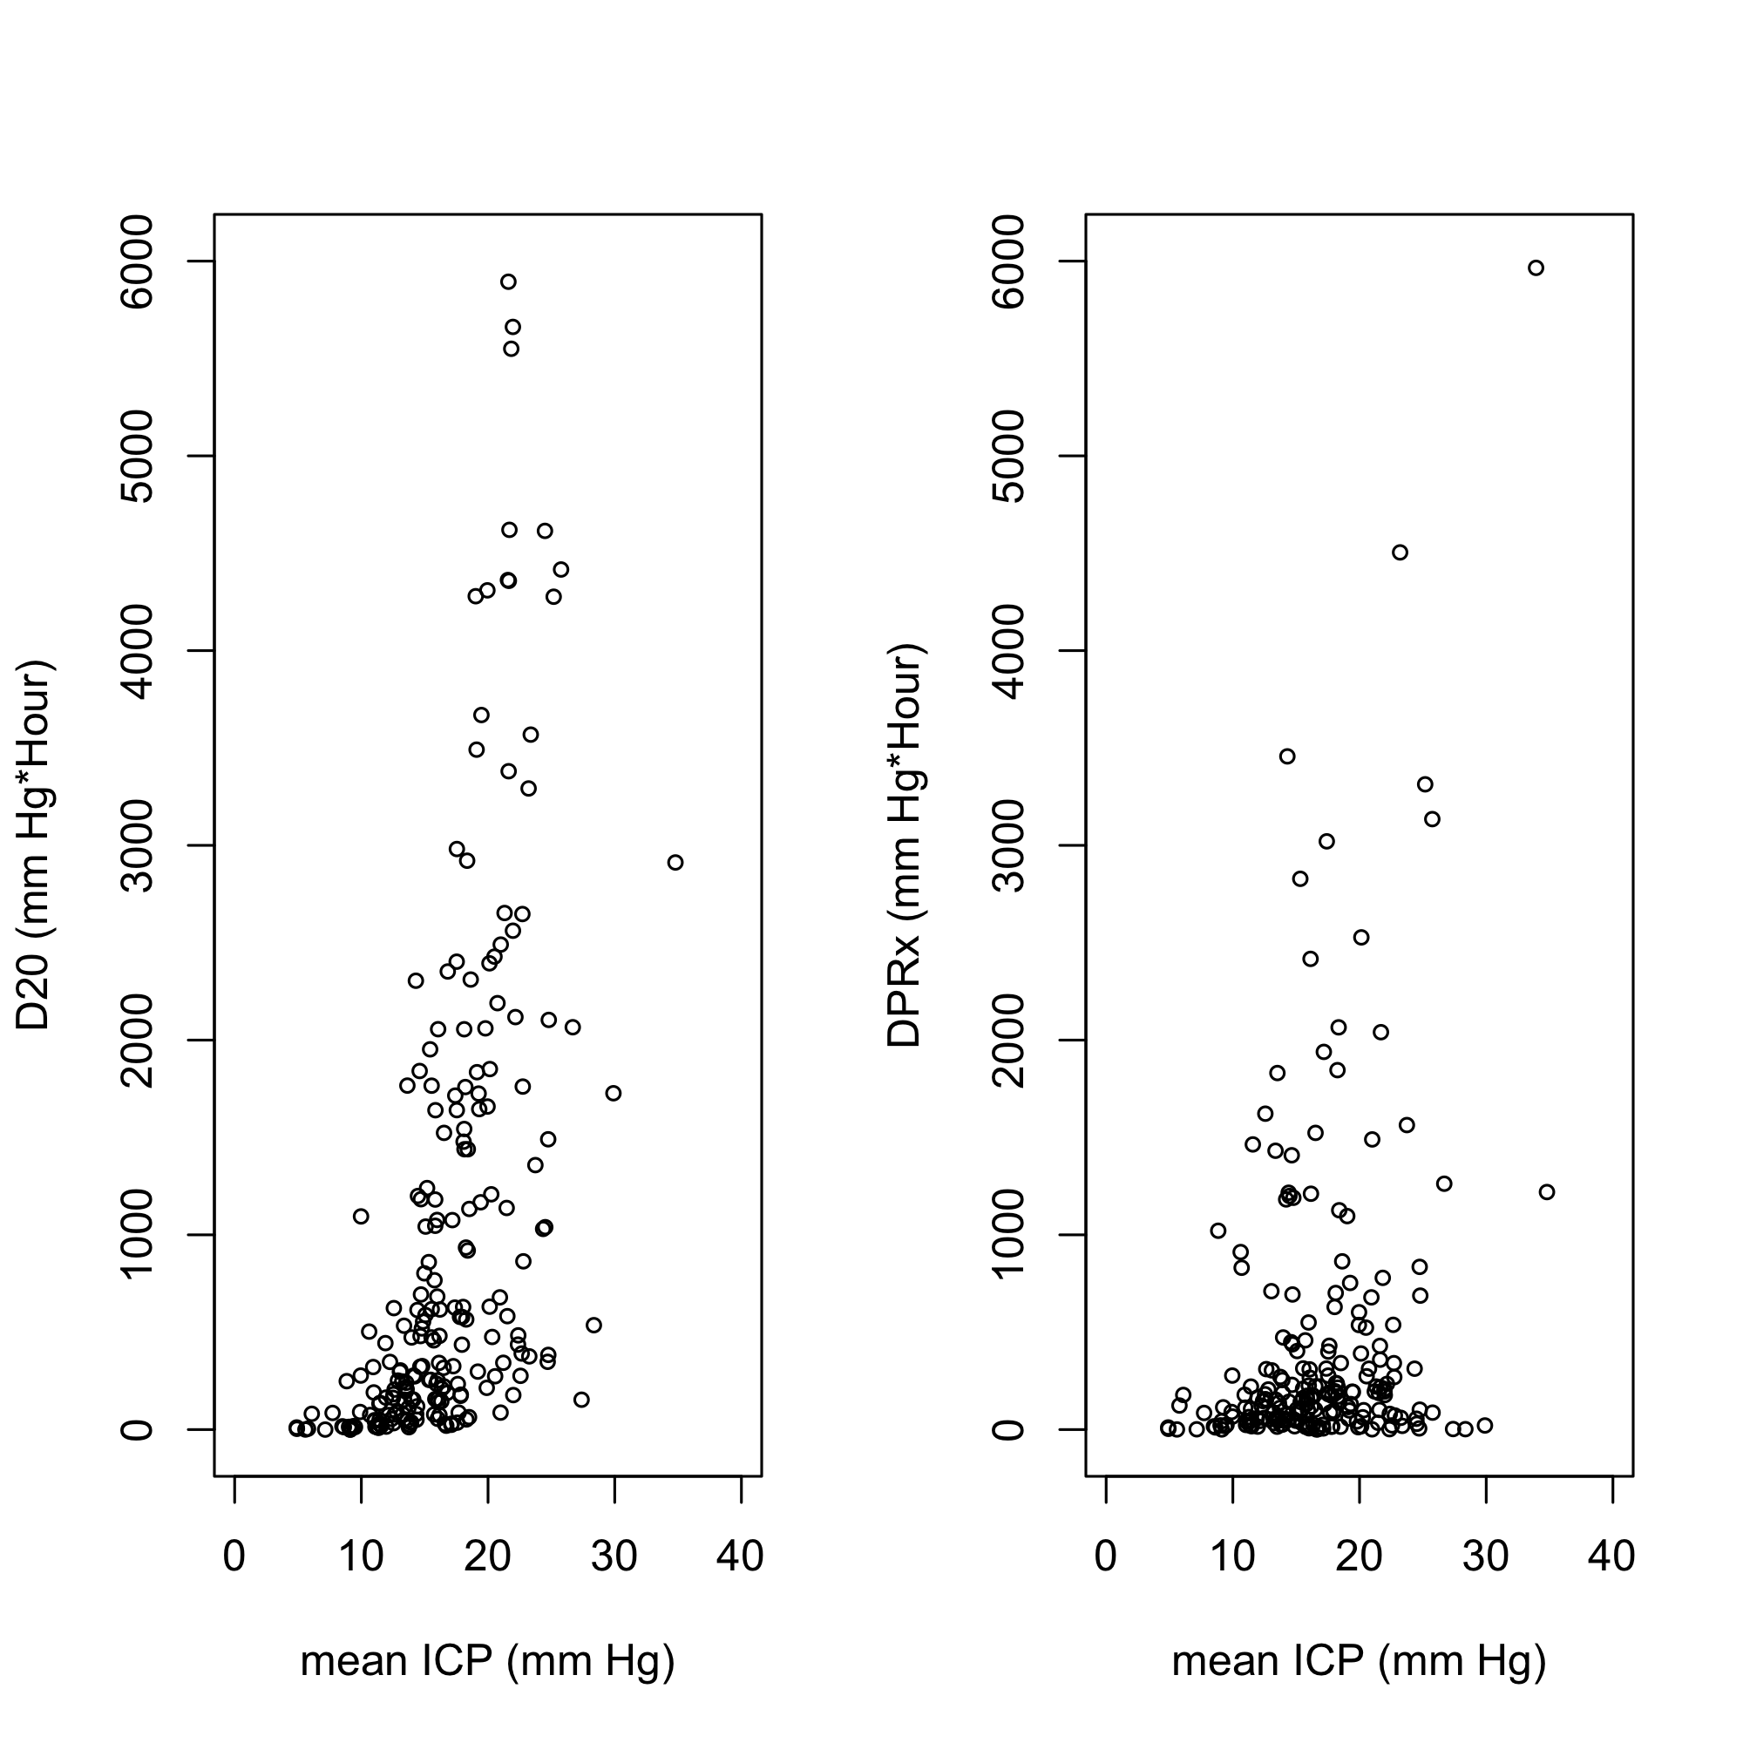

**Figure 1.** Relationship between D20, DPRx and mean ICP for the whole patient cohort. Higher D20 over DPRx can be appreciated in the range of 15-25 mm Hg of mean ICP.

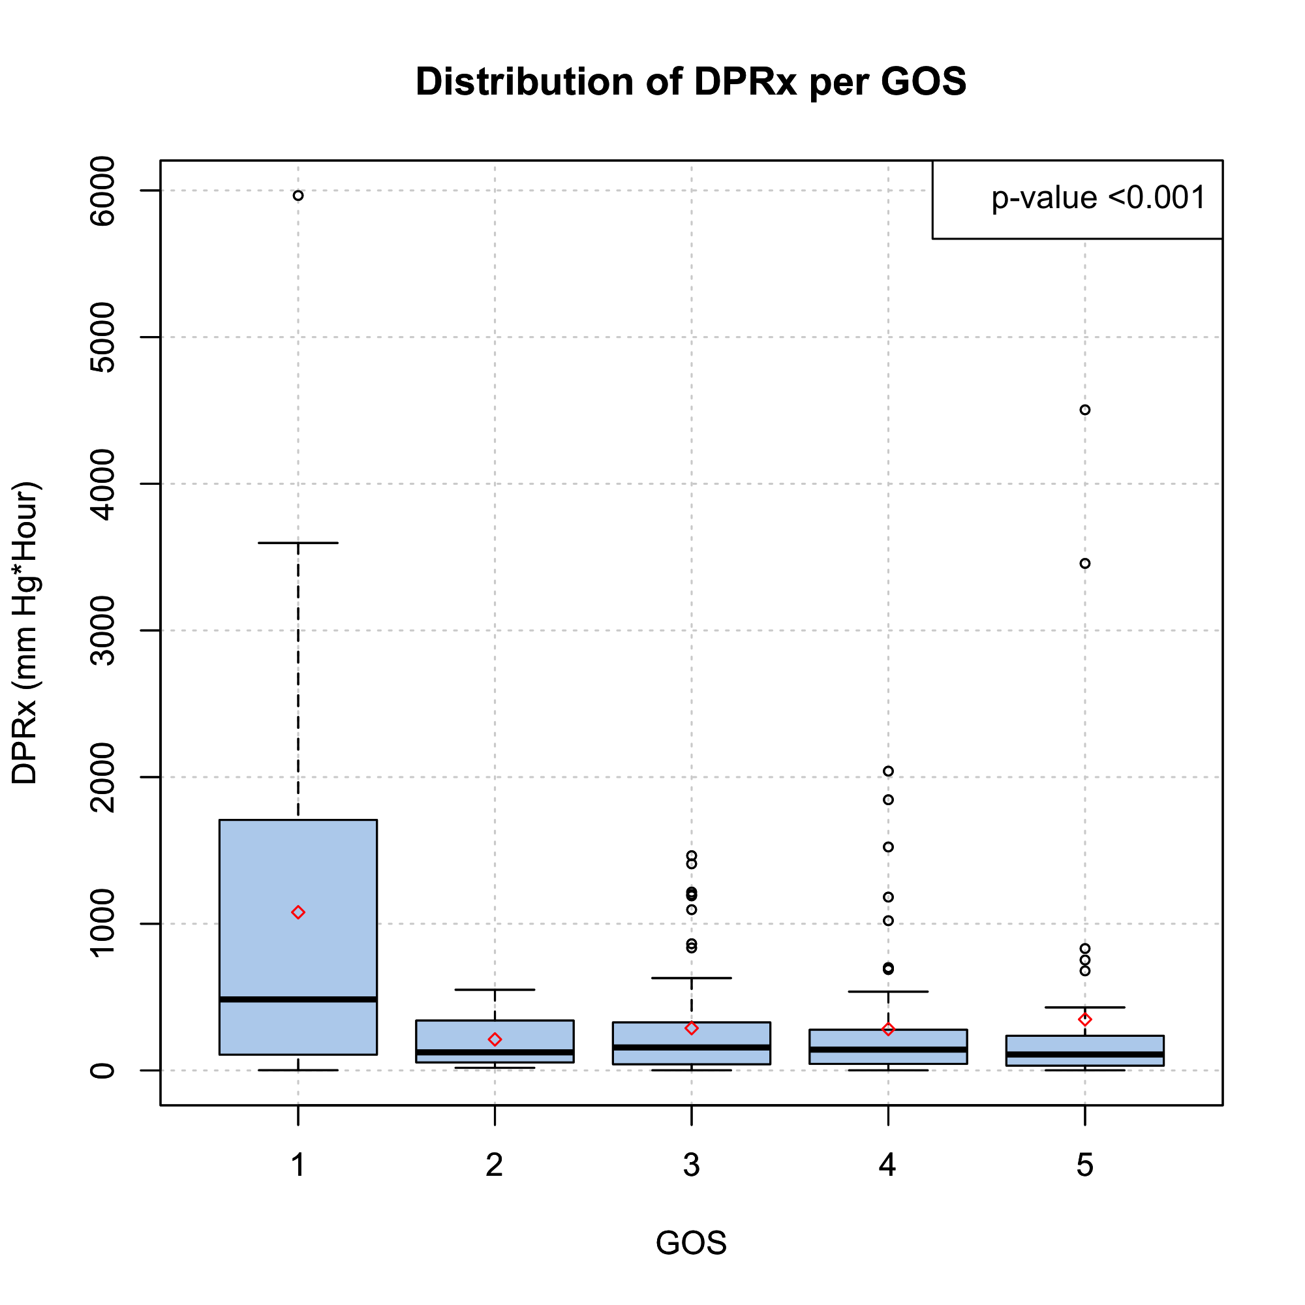

**Figure 2.** Distribution of DPRx across the GOS outcome categories. Significantly higher dose sustained by the patients who died (p < 0.001).